HOSPITAL MANAGEMENT SYSTEM
A DBMS Capstone Project Report submitted in partial fulfillment of the requirements for the award of the degree of
BACHELOR OF TECHNOLOGY
in
ARTIFICIAL INTELLIGENCE AND MACHINE LEARNING

Submitted By

G. YUVA CHANDU – 25B11AI310
M. SRIHARI – 25B11AI668
Y. ASHOKNANDA – 25B11AID07
K. PADMAKARA CHOWDARY – 25B11AI489

Under the esteemed guidance of
Mr. T.Srinivasulu M.Tech, (Ph.D.)

Assistant Professor


DEPARTMENT OF ARTIFICIAL INTELLIGENCE AND MACHINE LEARNING

ADITYA UNIVERSITY
(Formerly Aditya Engineering College (A))
Aditya Nagar, ADB Road, Surampalem, Andhra Pradesh, India
2026 – 2027


Aditya Nagar, ADB Road, Surampalem, Andhra Pradesh, India
DEPARTMENT OF ARTIFICIAL INTELLIGENCE AND MACHINE LEARNING

CERTIFICATE

This is to certify that the DBMS Capstone Project report entitled “HOSPITAL MANAGEMENT SYSTEM” is being submitted by G. YUVA CHANDU (25B11AI310), M. SRIHARI (25B11AI668), Y. ASHOKNANDA (25B11AID07) and K. PADMAKARA CHOWDARY (25B11AI489) in partial fulfillment of the requirements for the award of the B.Tech. degree in Artificial Intelligence and Machine Learning. The work documented in this report was carried out as part of the Capstone Project for the course Database Management Systems (2501IT05) during the academic year 2026–2027, and records the database design, implementation, and documentation undertaken by the team.

Project Guide Head of the Department
Mr. T. Srinivasulu, M. Tech, (Ph.D.) Dr. K. Naga Bhargavi, M. Tech, Ph.D.
Associate professor Associate Professor & HOD

External Examiner

DECLARATION
We hereby declare that the DBMS Capstone Project entitled “____________________________________________” is a genuine work carried out by us. The database design, SQL implementation, queries and documentation presented in this report are our own work, completed under the guidance of ____________________, Department of ____________________, Aditya University, Surampalem. We further declare that this work has not been submitted, in full or in part, for the award of any degree of this or any other educational institution.

Project Associates
____________________ (____________)
____________________ (____________)
____________________ (____________)
____________________ (____________)

Date: ____________
Place: Surampalem

ACKNOWLEDGEMENT

It is with immense pleasure that we express our indebted gratitude to our project guide
, Department of , who guided us throughout the capstone project. We are thankful for the constant encouragement and valuable suggestions received at every review stage.
We are grateful to , Head of the Department, for inspiring us and for arranging the facilities and resources needed for this project.
We extend our sincere thanks to the Management, Dr. M. Sreenivasa Reddy, Deputy Pro-Chancellor, Dr. M. B. Srinivas, Vice-Chancellor, and Dr. A. Ramesh, Pro Vice-Chancellor (Engineering & Sciences), for providing an excellent academic environment.
Not to forget, we thank the Teaching and Non-Teaching Staff, our parents and our friends, who have directly or indirectly supported us in completing this project on time.

Project Associates
Student Name Regd. No.
Student Name Regd. No.
Student Name Regd. No.
Student Name Regd. No.

ADITYA UNIVERSITY
Surampalem
Department of _Artificial intelligent and mechine learning_
DBMS CAPSTONE PROJECT
Project Documentation Report
Project Title: ____Hospital Management System_____
Submitted by:
S.No | Student Name | Roll Number
1. | G.YUVA CHANDU | 25B11AI310
2. | M.SRIHARI | 25B11AI668
3. | Y. ASHOKNANDA | 25B11AID07
4. | K. PADMAKARA CHOWDARY | 25B11AI489
Course: Database Management Systems (DBMS) Course Code: 2501IT05
Faculty Coordinator: THIRUVEEDULA SRINIVASULU
Academic Year: ____2______ Date of Submission: __________
GitHub Repository Link: https://github.com/yuvachandu233-stack/hospital-management-system

TABLE OF CONTENTS
TABLE OF CONTENTS 1
1. ABSTRACT 1
2. INTRODUCTION 1
2.1 Background 1
2.2 Purpose of the Database 1
3. PROBLEM STATEMENT 1
4. OBJECTIVES 1
5. TOOLS & TECHNOLOGIES USED 1
6. DATABASE DESIGN 1
6.1 Identified Entities 1
6.2 Entity Attributes 1
6.3 ER Diagram 1
6.4 Relationships & Cardinality 1
6.5 Relational Database Schema 1
6.6 Normalization 1
7. DATABASE IMPLEMENTATION 1
7.1 DDL — Database and Table Creation 1
7.2 Sample Data — DML 1
7.3 Constraints & Data Integrity 1
7.4 SQL Operations & Queries 1
7.5 Sample Outputs / Screenshots 1
8. MODULES & FUNCTIONALITIES 1
9. GITHUB REPOSITORY & TEAM RESPONSIBILITIES 1
10. ENHANCEMENTS & FUTURE IMPROVEMENTS 1
11. CONCLUSION 1
12. REFERENCES 1
APPENDIX 1
A. Complete SQL Script 1
B. Additional Screenshots / Outputs 1

1. ABSTRACT
The Hospital Management System (HMS) is a database-based application designed to manage and organize important hospital operations through a centralized relational database. The system focuses on maintaining patient information, doctor and department details, appointment scheduling, billing records, staff information, medicines and stock, and prescriptions. The proposed database addresses limitations of manual hospital management such as large volumes of paperwork, slow information retrieval, duplicate or inconsistent records, appointment-management difficulties, and errors in billing or prescription records. The design identifies eight core entities—Patient, Doctor, Department, Appointment, Billing, Staff, Medicine, and Prescription—and defines their attributes, primary keys, foreign keys, relationships, and cardinalities. The model uses one-to-many relationships and an indirect many-to-many relationship between patients and doctors through appointments. The design also emphasizes data integrity through primary and foreign keys and database constraints. The first review completed requirement identification, entity and attribute identification, ER modelling, relationship/cardinality analysis, key identification, and relational schema design. Database implementation, sample data, SQL queries, reports, testing, and interface integration are planned for Review-II.

2. INTRODUCTION

2.1 Background
A Hospital Management System is a database-based application intended to manage and organize important hospital operations using a centralized relational database. The system brings related hospital information into a structured design so that records can be stored, retrieved, and connected consistently.
The system manages:
Patient information
Doctor and department details
Appointment scheduling
Billing records
Staff information
Medicines and stock
Prescriptions
Why a database is required:
Centralized and organized data storage
Faster retrieval of patient information
Reduced data redundancy
Improved data consistency
Better coordination between hospital activities
Secure and reliable record management

2.2 Purpose of the Database
The purpose of the database is to provide a centralized relational structure for storing, organizing, retrieving, and managing hospital information. It connects patients, doctors, departments, appointments, billing, medicines, prescriptions, and staff while maintaining relationships through primary and foreign keys. The intended users include hospital administrative staff and other authorized personnel who need organized access to operational records.

3. PROBLEM STATEMENT
Traditional/manual hospital management can create several difficulties:
Patient records may be maintained using large amounts of paperwork.
Retrieving patient information can be slow.
Duplicate or inconsistent records may occur.
Appointment scheduling can become difficult to manage.
Billing and prescription records may contain errors.
Information may not be easily shared between hospital departments.
Maintaining relationships between patients, doctors, appointments and medicines can be difficult.
Problem addressed: The proposed Hospital Management System provides a centralized relational database to store, organize, retrieve and manage hospital information efficiently.
4. OBJECTIVES
- Objective 1: Maintain centralized and structured patient records.
- Objective 2: Manage doctors, departments and appointments efficiently.
- Objective 3: Store prescriptions and medicine information in an organized database.
- Objective 4: Support accurate billing and hospital record management.
- Objective 5: Maintain data integrity using primary keys, foreign keys and database constraints.
5. TOOLS & TECHNOLOGIES USED

Category | Tool / Technology Used
Database Server | Relational DBMS — exact product/version to be confirmed
Query / Admin Tool | SQL client/admin tool — to be confirmed
Front-end (if any) | Not specified in Review-I; planned for application interface integration
Operating System | Not specified in Review-I
Version Control | GitHub repository — link not provided
6. DATABASE DESIGN

6.1 Identified Entities
S.No | Entity Name | Description
1 | PATIENT | Stores patient personal and contact information.
2 | DOCTOR | Stores doctor details, specialization and department information.
3 | DEPARTMENT | Stores hospital department details.
4 | APPOINTMENT | Stores appointment information between patients and doctors.
5 | BILLING | Stores patient billing and payment information.
6 | STAFF | Stores information about hospital employees.
7 | MEDICINE | Stores medicine details, price and available stock.
8 | PRESCRIPTION | Stores medicines prescribed during appointments.

6.2 Entity Attributes
Entity | Attribute | Data Type | Key | Attribute Type
PATIENT | Patient_ID | INT | PK | Simple
PATIENT | Name | VARCHAR | — | Simple
PATIENT | Age | INT | — | Simple
PATIENT | Gender | VARCHAR | — | Simple
PATIENT | Phone | VARCHAR | — | Simple
PATIENT | Address | VARCHAR | — | Simple
PATIENT | Blood_Group | VARCHAR | — | Simple
DOCTOR | Doctor_ID | INT | PK | Simple
DOCTOR | Name | VARCHAR | — | Simple
DOCTOR | Specialization | VARCHAR | — | Simple
DOCTOR | Experience | INT | — | Simple
DOCTOR | Phone | VARCHAR | — | Simple
DOCTOR | Department_ID | INT | FK | Simple
DEPARTMENT | Department_ID | INT | PK | Simple
DEPARTMENT | Department_Name | VARCHAR | — | Simple
DEPARTMENT | Floor | INT | — | Simple
APPOINTMENT | Appointment_ID | INT | PK | Simple
APPOINTMENT | Patient_ID | INT | FK | Simple
APPOINTMENT | Doctor_ID | INT | FK | Simple
APPOINTMENT | Date | DATE | — | Simple
APPOINTMENT | Time | TIME | — | Simple
APPOINTMENT | Status | VARCHAR | — | Simple
BILLING | Bill_ID | INT | PK | Simple
BILLING | Patient_ID | INT | FK | Simple
BILLING | Amount | DECIMAL | — | Simple
BILLING | Payment_Mode | VARCHAR | — | Simple
BILLING | Date | DATE | — | Simple
STAFF | Staff_ID | INT | PK | Simple
STAFF | Name | VARCHAR | — | Simple
STAFF | Position | VARCHAR | — | Simple
STAFF | Salary | DECIMAL | — | Simple
MEDICINE | Medicine_ID | INT | PK | Simple
MEDICINE | Medicine_Name | VARCHAR | — | Simple
MEDICINE | Price | DECIMAL | — | Simple
MEDICINE | Stock | INT | — | Simple
PRESCRIPTION | Prescription_ID | INT | PK | Simple
PRESCRIPTION | Appointment_ID | INT | FK | Simple
PRESCRIPTION | Medicine_ID | INT | FK | Simple
PRESCRIPTION | Dosage | VARCHAR | — | Simple

6.3 ER Diagram.
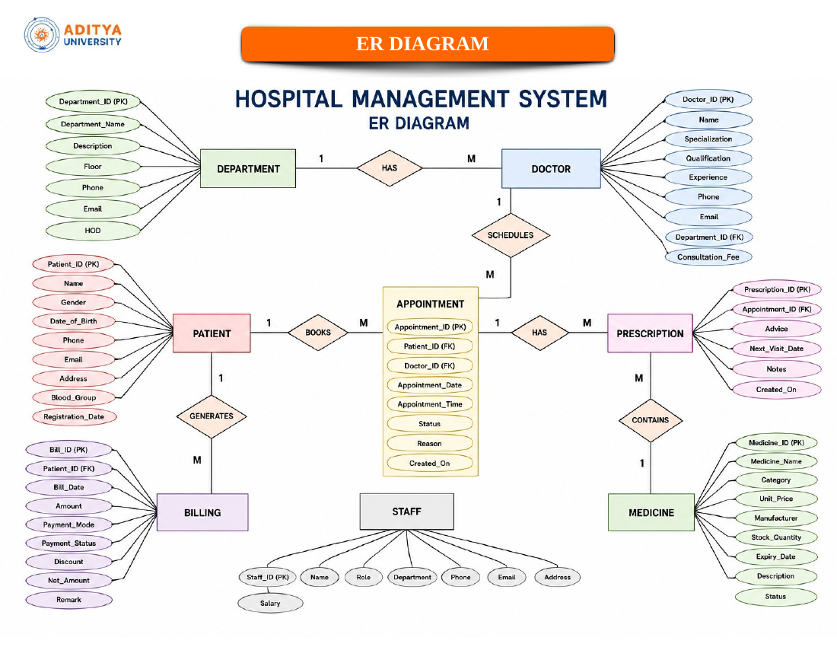

6.4 Relationships & Cardinality
Entity 1 | Relationship | Entity 2 | Cardinality | Description
DEPARTMENT | Has / Contains | DOCTOR | 1 : M | One department can have many doctors.
PATIENT | Has | APPOINTMENT | 1 : M | One patient can have many appointments.
DOCTOR | Has | APPOINTMENT | 1 : M | One doctor can have many appointments.
PATIENT | Has | BILLING | 1 : M | One patient can have multiple billing records.
APPOINTMENT | Has | PRESCRIPTION | 1 : M | One appointment can have multiple prescription records.
MEDICINE | Appears in | PRESCRIPTION | 1 : M | One medicine can appear in multiple prescription records.

Note: PATIENT and DOCTOR have an indirect M : N relationship through APPOINTMENT.

6.5 Relational Database Schema

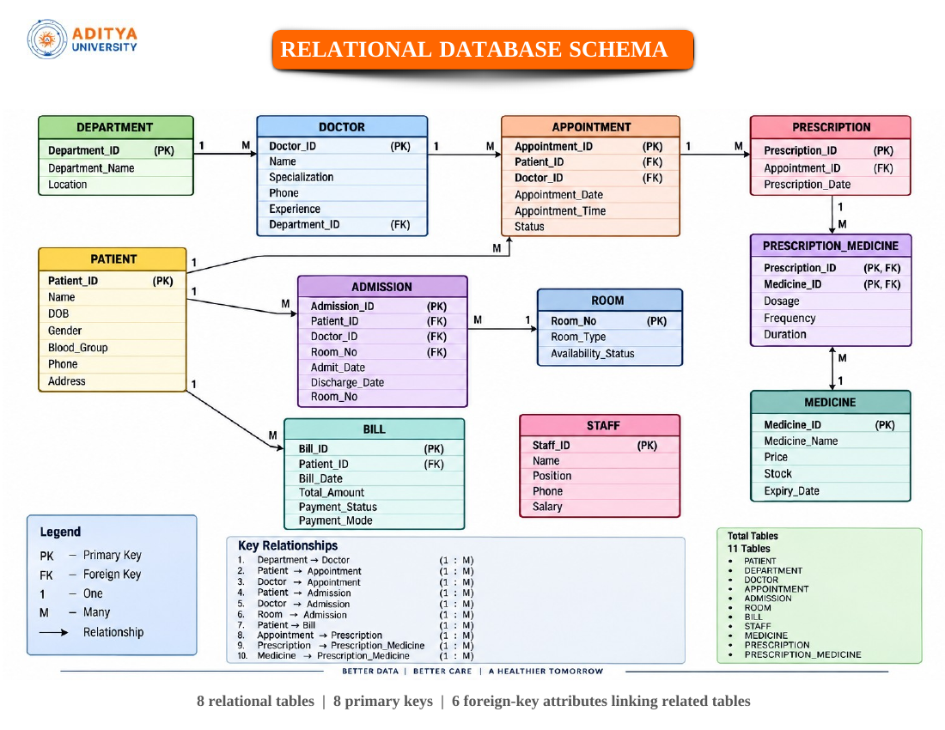

The design contains 8 relational tables, 8 primary keys and 6 foreign-key attributes linking related tables.
Table Name | Column Name | Data Type | PK/FK/— | Constraints
PATIENT | Patient_ID | INT | PK | Not Null
PATIENT | Name | VARCHAR | —
PATIENT | Age | INT | —
PATIENT | Gender | VARCHAR | —
PATIENT | Phone | VARCHAR | —
PATIENT | Address | VARCHAR | —
PATIENT | Blood_Group | VARCHAR | —
DOCTOR | Doctor_ID | INT | PK | Not Null
DOCTOR | Name | VARCHAR | —
DOCTOR | Specialization | VARCHAR | —
DOCTOR | Experience | INT | —
DOCTOR | Phone | VARCHAR | —
DOCTOR | Department_ID | INT | FK | References DEPARTMENT
DEPARTMENT | Department_ID | INT | PK | Not Null
DEPARTMENT | Department_Name | VARCHAR | —
DEPARTMENT | Floor | INT | —
APPOINTMENT | Appointment_ID | INT | PK | Not Null
APPOINTMENT | Patient_ID | INT | FK | References PATIENT
APPOINTMENT | Doctor_ID | INT | FK | References DOCTOR
APPOINTMENT | Date | DATE | —
APPOINTMENT | Time | TIME | —
APPOINTMENT | Status | VARCHAR | —
BILLING | Bill_ID | INT | PK | Not Null
BILLING | Patient_ID | INT | FK | References PATIENT
BILLING | Amount | DECIMAL | —
BILLING | Payment_Mode | VARCHAR | —
BILLING | Date | DATE | —
STAFF | Staff_ID | INT | PK | Not Null
STAFF | Name | VARCHAR | —
STAFF | Position | VARCHAR | —
STAFF | Salary | DECIMAL | —
MEDICINE | Medicine_ID | INT | PK | Not Null
MEDICINE | Medicine_Name | VARCHAR | —
MEDICINE | Price | DECIMAL | —
MEDICINE | Stock | INT | —
PRESCRIPTION | Prescription_ID | INT | PK | Not Null
PRESCRIPTION | Appointment_ID | INT | FK | References APPOINTMENT
PRESCRIPTION | Medicine_ID | INT | FK | References MEDICINE
PRESCRIPTION | Dosage | VARCHAR | —

6.6 Normalization

The supplied Review-I presentation establishes separate entities and relational tables but does not provide a written normalization derivation. Based on the proposed schema, the intended normalization path is:
Stage | Description
UNF | A conceptual collection of hospital records before decomposition into separate relations.
1NF | Attributes are represented as atomic fields and repeating groups are separated into relational records.
2NF | Non-key attributes are organized so that they depend on the complete primary key of their relation.
3NF | Non-key attributes are kept dependent on the key rather than on other non-key attributes; relationships are represented through foreign keys.

UNF → 1NF → 2NF → 3NF

This normalization explanation describes the intended design principle; a formal dependency analysis was not included in the Review-I source.
7. DATABASE IMPLEMENTATION

7.1 Patient Table
Attribute | Data Type | Constraint | Description
patient_id | INT | PK | Unique patient identifier
first_name | VARCHAR(50) | NOT NULL | Patient first name
last_name | VARCHAR(50) | NOT NULL | Patient last name
dob | DATE | NOT NULL | Date of birth
blood_group | VARCHAR(5) | NOT NULL | Blood group
gender | VARCHAR(15) | NOT NULL | Gender
address | VARCHAR(255) | NOT NULL | Patient address

7.2 Patient_Contact Table
Attribute | Data Type | Constraint | Description
contact_id | INT | PK | Unique contact record
patient_id | INT | FK | References Patient
contact_number | VARCHAR(15) | NOT NULL, UNIQUE | Patient contact number
contact_type | VARCHAR(20) | NOT NULL | Contact type

7.3 Doctor Table
Attribute | Data Type | Constraint | Description
doctor_id | INT | PK | Unique doctor identifier
first_name | VARCHAR(50) | NOT NULL | Doctor first name
last_name | VARCHAR(50) | NOT NULL | Doctor last name
specialization | VARCHAR(100) | NOT NULL | Medical specialization
experience_years | INT | CHECK >= 0 | Experience in years
email | VARCHAR(120) | UNIQUE | Doctor email
dept_id | INT | FK | References Department

7. TABLE DESIGN – II

7.4 Department Table
Attribute | Data Type | Constraint | Description
dept_id | INT | PK, AUTO_INCREMENT | Department identifier
dept_name | VARCHAR(100) | NOT NULL, UNIQUE | Department name
hod_doctor_id | INT | FK | Head doctor reference
floor_no | INT | NOT NULL | Department floor

7.5 Ward Table
Attribute | Data Type | Constraint | Description
ward_id | INT | PK, AUTO_INCREMENT | Ward identifier
ward_name | VARCHAR(100) | NOT NULL | Ward name
capacity | INT | CHECK > 0 | Ward capacity
available_beds | INT | Derived / maintained | Available beds
dept_id | INT | FK | References Department

7.6 Appointment Table
Attribute | Data Type | Constraint | Description
appt_id | INT | PK, AUTO_INCREMENT | Appointment identifier
patient_id | INT | FK, NOT NULL | Patient reference
doctor_id | INT | FK, NOT NULL | Doctor reference
appointment_date | DATE | NOT NULL | Appointment date
appointment_time | TIME | NOT NULL | Appointment time
status | VARCHAR(20) | NOT NULL | Appointment status

7. TABLE DESIGN – III & NORMALIZATION

7.7 Treatment Table
Attribute | Data Type | Constraint | Description
treatment_id | INT | PK, AUTO_INCREMENT | Treatment identifier
appt_id | INT | FK, UNIQUE | Appointment reference
diagnosis | VARCHAR(255) | NOT NULL | Diagnosis details
treatment_date | DATE | NOT NULL | Treatment date
ward_id | INT | FK | Ward reference

7.8 Prescription Table
Attribute | Data Type | Constraint | Description
prescription_id | INT | PK, AUTO_INCREMENT | Prescription identifier
treatment_id | INT | FK | Treatment reference
medicine_name | VARCHAR(120) | NOT NULL | Medicine name
dosage | VARCHAR(60) | NOT NULL | Dosage
frequency | VARCHAR(50) | NOT NULL | Frequency
duration | INT | CHECK > 0 | Duration

7.9 Bill Table
Attribute | Data Type | Constraint | Description
bill_id | INT | PK, AUTO_INCREMENT | Bill identifier
patient_id | INT | FK, NOT NULL | Patient reference
treatment_id | INT | FK, UNIQUE | Treatment reference
consultation_fee | DECIMAL(10,2) | NOT NULL | Consultation charge
medicine_charges | DECIMAL(10,2) | NOT NULL | Medicine charge
bed_charges | DECIMAL(10,2) | NOT NULL | Bed charge
total_amount | DECIMAL(10,2) | Derived | Total amount
payment_status | VARCHAR(20) | NOT NULL | Payment status
bill_date | DATE | NOT NULL | Bill date

7.10 Normalization

The database is organized into separate relations to reduce redundancy and update anomalies. In 1NF, attributes are atomic and repeating groups are separated. In 2NF, attributes depend on their appropriate identifiers rather than partial composite-key dependencies. In 3NF, department, doctor, patient, appointment, treatment, prescription and billing information are separated so that transitive dependencies are reduced and relationships are represented through foreign keys.

8. MODULES & FUNCTIONALITIES
S.No | Module Name | Functionality
1 | Patient Management | Maintain patient personal and contact information.
2 | Doctor Management | Maintain doctor details, specialization, experience, phone and department association.
3 | Department Management | Maintain department names and floor information.
4 | Appointment Management | Store appointments linking patients and doctors with date, time and status.
5 | Billing Management | Maintain patient billing records, amounts, payment modes and dates.
6 | Staff Management | Maintain hospital employee information, positions and salary.
7 | Medicine Management | Maintain medicine names, prices and available stock.
8 | Prescription Management | Store prescription records linking appointments and medicines with dosage.

9. GITHUB REPOSITORY & TEAM RESPONSIBILITIES

Repository Link: https://github.com/yuvachandu233-stack/hospital-management-system

Student Name | Roll Number | Role / Responsibility
G. Yuva Chandu | 25B11AI310 | Team Lead – Coordination, Database Design & Presentation
M. Srihari | 25B11AI668 | Patient & Doctor Module
Y. Ashoknanda | 25B11AID07 | Appointment & Treatment Module
K. Padmakara Chowdary | 25B11AI489 | Billing, Testing & Documentation

10. ENHANCEMENTS & FUTURE IMPROVEMENTS

Implement all database tables in SQL.

Add primary-key, foreign-key and other finalized constraints.

Insert and validate sufficient sample records.

Develop representative SQL queries, joins, aggregate reports, GROUP BY/HAVING queries, subqueries and views.

Perform database testing and capture execution screenshots.

Integrate an application interface with the database.

Improve security and controlled access to hospital records.

Add reporting and dashboard capabilities.

Improve performance and scalability as the database grows.

Extend the system with additional hospital modules if required.

11. CONCLUSION

The Hospital Management System provides a structured relational database design for managing important hospital operations. The proposed model connects patients, doctors, departments, appointments, billing, medicines and prescriptions, while maintaining data consistency through primary keys, foreign keys and database constraints. The design can reduce manual work, improve information retrieval, minimize data redundancy and support efficient hospital management. The Review-I work completed requirement identification, entity and attribute identification, ER model design, relationship and cardinality analysis, primary and foreign key identification, and relational schema design. Review-II will focus on implementing the database in SQL, inserting sample data, applying constraints, executing queries, generating reports, testing the database, and integrating the application interface.

12. REFERENCES

The supplied materials did not list external references. The following project materials were used as the basis for completing this report:

1. Hospital Management System — Database Management Systems Cornerstone Project, First Review presentation supplied with this task.

2. DBMS Capstone Project — Project Documentation Report template supplied with this task.

External textbooks/web resources were not specified in the supplied source and have therefore not been claimed as project references.

APPENDIX

A. Complete SQL Script

The following is the proposed Review-II DDL draft based on the Review-I relational schema. It should be executed and tested before being treated as the final implementation.

CREATE DATABASE Hospital_Management_System;
USE Hospital_Management_System;
CREATE TABLE Department (
Department_ID INT PRIMARY KEY,
Department_Name VARCHAR(100),
Floor INT
);
CREATE TABLE Patient (
Patient_ID INT PRIMARY KEY,
Name VARCHAR(100),
Age INT,
Gender VARCHAR(20),
Phone VARCHAR(20),
Address VARCHAR(200),
Blood_Group VARCHAR(10)
);
CREATE TABLE Doctor (
Doctor_ID INT PRIMARY KEY,
Name VARCHAR(100),
Specialization VARCHAR(100),
Experience INT,
Phone VARCHAR(20),
Department_ID INT,
FOREIGN KEY (Department_ID) REFERENCES Department(Department_ID)
);
CREATE TABLE Appointment (
Appointment_ID INT PRIMARY KEY,
Patient_ID INT,
Doctor_ID INT,
Date DATE,
Time TIME,
Status VARCHAR(30),
FOREIGN KEY (Patient_ID) REFERENCES Patient(Patient_ID),
FOREIGN KEY (Doctor_ID) REFERENCES Doctor(Doctor_ID)
);
CREATE TABLE Billing (
Bill_ID INT PRIMARY KEY,
Patient_ID INT,
Amount DECIMAL(10,2),
Payment_Mode VARCHAR(30),
Date DATE,
FOREIGN KEY (Patient_ID) REFERENCES Patient(Patient_ID)
);
CREATE TABLE Staff (
Staff_ID INT PRIMARY KEY,
Name VARCHAR(100),
Position VARCHAR(100),
Salary DECIMAL(10,2)
);
CREATE TABLE Medicine (
Medicine_ID INT PRIMARY KEY,
Medicine_Name VARCHAR(100),
Price DECIMAL(10,2),
Stock INT
);
CREATE TABLE Prescription (
Prescription_ID INT PRIMARY KEY,
Appointment_ID INT,
Medicine_ID INT,
Dosage VARCHAR(100),
FOREIGN KEY (Appointment_ID) REFERENCES Appointment(Appointment_ID),
FOREIGN KEY (Medicine_ID) REFERENCES Medicine(Medicine_ID)
);

B. Additional Screenshots / Outputs

Review-I source evidence included the ER diagram and relational database schema. SQL execution screenshots, sample data outputs and testing evidence are to be added after Review-II implementation.

7.5 Sample Outputs / Screenshots
Figure 1: __patient details
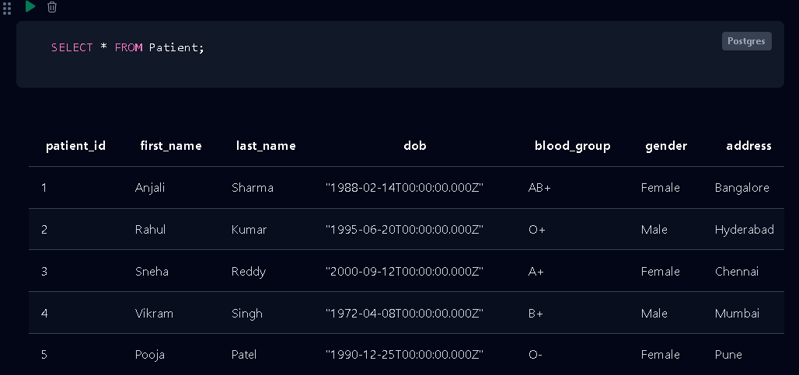
Figure 2: appointment_date
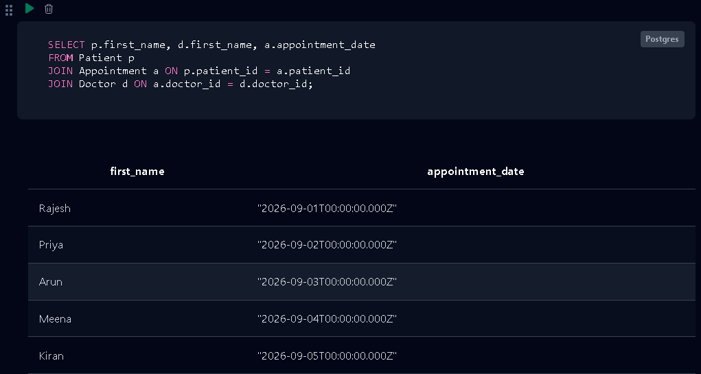
Figure 3: insert doctor details
